44TH BRINKWORTH ANNUAL PRODUCE AND HANDICRAFT SHOW
www.brinkworthflowershow.com

SUNDAY, 31ST AUGUST 2025

To be held at Brinkworth Show
Brinkworth Recreation Field, SN15 5AH

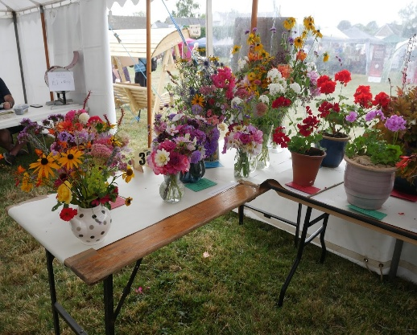 | 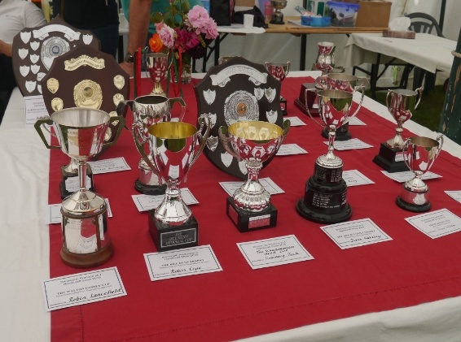 | 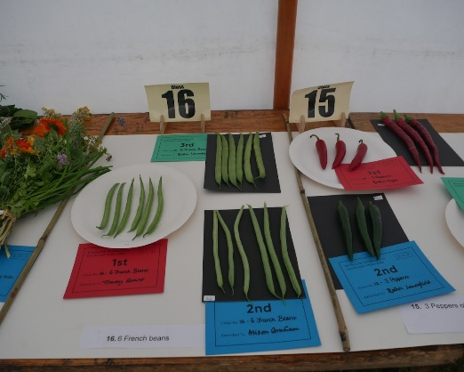
Please deliver completed entry forms to:

CHERRY TREES, STOPPERS HILL, BRINKWORTH, SN15 5DW
By 4pm on Friday 29th August 2025

Timings for Produce and Handicraft Show

8am – 9.30am | Drop of exhibits at marquee for staging
10am | Judging commences
11am | Main Show Opens to public
11am – 1pm | Raffle tickets for sale at the entrance of the Produce & Handicraft marquee
1pm | Produce & Handicraft Marquee opens to the public
4pm | Children collect prize money
4.15pm | Raffle prizes
4.30pm | Presentation of Cups/Trophies and Prizes
4.45pm | Auction of all donated entries

Produce & Handicraft Show Secretary
Tuesday Sawyer 07867 690477

Chair
Mr Chris Walton 01666 510557

ENTRY RULES

- All entry forms to be returned to the Show Secretary by
Friday 29th August 2025, not later than 4pm.
NO ENTRY FORMS WILL BE ACCEPTED AFTER THIS TIME.
- One entry form for each exhibitor, please download an entry form per person or get a printed copy from the Secretary if required.
- Entry Fees: All adult classes 50p. Children’s classes H, I & J Free
- Maximum of two entries per person, per class but only one certificate per person, per class will be awarded.
- All produce shown must have been grown in the gardens or allotments of the exhibitors.
- All exhibits to be staged between 8.00am and 9.30am on Sunday 31st August 2025 in the Recreation Field Marquee.
- Judging will commence at 10.00am sharp.
- Prizes will be awarded as detailed under “Prizes and Cups”

THE JUDGE’S DECISION WILL BE FINAL

Note: Whilst every care will be taken, the Produce and Handicraft Show Committee will not be responsible for any loss or damage to the exhibits, containers or any other items belonging to the exhibitors. Children’s prize money can be collected from 4pm and the Cups will be presented at 4.30pm followed by the Auction of donated entries.

Please Note: Please use the entrance for the Recreation Field from the B4042 marked with a sign for Brinkworth Village Show. You will be able to drive up to and park near the rear entrance of the marquee to set up your entries. You will be expected to leave the Recreation Field in time for judging to commence at 10.00am.

The Recreation Field will re-open at 11.00am for the day’s attractions. The Produce and Handicraft marquee, showing your exhibits, will open at 1.00pm for viewing.

Exhibits should be clearly marked NFS if they are not for sale. Please do not remove exhibits from display until 4.00pm so that everyone can enjoy seeing them. Items not marked NFS (or donated by exhibitors) will be sold by auction after prize giving at 4.30pm to help to raise money towards the running costs of the show.

CUPS AND PRIZES

The Walton Family Cup |  | Most points gained in sections A-C (Vegetables and Fruit)
The Bill Dunn Trophy |  | Outstanding exhibit in sections A-C
The Wanborough Herb Nursery Cup |  | Best exhibit in section 17
The Adams Family Trophy |  | Most points gained in section D (Floral Art)
The Wakely Cup |  | Best exhibit in section D
The Slade Family Cup |  | Most points gained in section E (Flowers and Plants)
The Logan Family Cup |  | Outstanding exhibit in section E
The John Magill Memorial Shield |  | Best photograph in section F
The Bennett Trophy |  | Most points gained in section F
The Howells Family Cup |  | Most points gained in section G (Domestic Classes)
The Malcolm Scott Memorial Shield |  | Best exhibit in class 74 (eggs)
The Miss M. A. Brown Cup |  | Best specimen handwriting under 8 years
The Jean Lambe Memorial Cup |  | Best specimen handwriting 8-11 years
The Brinkworth Brownie Cup |  | Most points gained in section H Children under 8 years  (Excl. handwriting)
The Brinkworth Carnival Committee Shield |  | Most points gained in section I Children 8-11 (excl. handwriting)
The Bennett Cup |  | Most points gained in section J Children up to 16 years
The Brinkworth W.I. Cup |  | Most points gained in section K (Handicrafts)
The Beavis Family Cup Junior |  | Best photograph from 8 - 11 years old Section I
The Beavis Family Cup Senior |  | Best photograph from 11 up to 16 years old Section J
The Three Crowns Cup |  | Best exhibit in Class 75-77
Brinkworth Master Chef’s Hat |  | Class 71 Cake “Men Only”
Points & Prizes Money will be awarded as follows
 | 1st |  | 2nd | 3rd
Childrens Classes  Section H, I & J | £1 |  | 60p | 40p
Adult Classes | NO PRIZE MONEY
All Classes | 3 points |  | 2 points | 1 point

Class | SECTION A – VEGETABLES CLASSES 1-18
 | ALL ROOT VEGETABLES TO HAVE 2” GREEN TOP
1 | 3 Potatoes (white)
2 | 3 Potatoes (coloured)
3 | 3 Beetroot
4 | 6 Runner beans
5 | 4 Tomatoes (not cherry)
6 | 6 Cherry Tomatoes
7 | 3 Carrots any variety
8 | 2 Parsnips
9 | 2 Courgettes
10 | 3 Sticks of Rhubarb
11 | 1 Cucumber
12 | 2 Leeks
13 | 3 Onions - under 250g
14 | 6 Shallots
15 | 3 Peppers of the same variety (including chillies)
16 | 6 French beans
17 | Tied Bunch of Culinary Herbs (minimum 3 varieties)
18 | A collection of any vegetables from the schedule
Class | SECTION B – FUN VEGETABLES CLASSES 19-23
19 | Wonkiest vegetable
20 | Heaviest marrow
21 | Largest Onion
22 | Longest runner bean
23 | Heaviest Potato
Class | SECTION C – FRUIT CLASSES 24-28
24 | 4 Apples, cooking
25 | 4 Apples, dessert
26 | 1 dish of soft fruit (minimum 15 berries)
27 | 4 Pears
28 | Any other fruit not in schedule (please identify type of fruit with a label)

JUDGING STANDARDS ARE BASED ON “THE ROYAL HORTICULTURAL SHOW HANDBOOK” for more information or to get your own copy the ISBN No. is 9781907057656 available from all good bookstores.

Most of the guidance and tips for Section A, B C, D and E are taken from the RHS Horticultural Show Handbook.

DON’T FORGET TO LOOK AT THE HELPFUL GUIDANCE AND TIPS ON PAGES 12 & 13

Class | SECTION D – FLORAL ART CLASSES 29-32
29 | An Arrangement in an Open Box (any size)
30 | An Arrangement in a Teapot (any size)
31 | An Arrangement in a Picture Frame (any size) Guidance and tips for the picture frame on Brinkworth flower show website click on “Helpful Hints then Tips for Floral Art”
32 | Novice Class. An Oval Table Arrangement (any size) – Candles optional
A Novice is a person who has not previously won a First Prize in Floral Art Classes 29, 30, 31 in previous years.
Class | SECTION E – FLOWERS AND PLANTS CLASSES 33-48
33 | A collection of mixed garden flowers
34 | 1 Geranium/Pelargonium
35 | Pot Plant – flowering (home-grown) indoors or outdoors
36 | Vase of mixed foliage (no flowers)
37 | Sunflower Head 1 stem (any variety)
38 | 2 Spikes of Gladioli
39 | 5 Stems of Sweet Peas
40 | 1 Spray of Cluster Roses
41 | 1 Rose bloom
42 | 4 Rose blooms of one or mixed varieties
43 | 1 Hydrangea bloom
44 | 3 Dahlia blooms of any one variety
45 | 3 Pom-Pon Dahlia blooms – must not exceed 55 mm in diameter
46 | 3 Decorative Dahlia blooms (other than above)
47 | 3 Specimen stems of one herbaceous plant
48 | 1 Specimen cut bloom (any variety)
Class | SECTION F – PHOTOGRAPHY CLASSES 53-58
53 | This Winter’s Floods & Frost
54 | Dusk Til Dawn
55 | Pollinators
56 | Village Events
57 | Reflections
58 | That is unusual!
Size of print no larger than 7”x5” or 180mm x 125mm, unframed and unmounted. Only one entry per class per person

Class | SECTION G – DOMESTIC CLASSES 59-77
59 | Jar of curd any variety
60 | Jar of jam of any fruit
61 | Jar of jelly of any fruit
62 | Jar of chutney
63 | Jar of honey
64 | Jar of marmalade
65 | 6 Cheese scones
66 | A novelty cake or Show Stopper
67 | Any loaf of bread, homemade
68 | Condensed Milk Cake – a recipe from 1945 in support of 80th Anniversary of VE day (see recipe attached)
69 | Coffee Sponge (with coffee butter cream) - (3 eggs)
70 | Easy mix show fruit cake (see recipe attached)
71 | Men only: I Can’t Cook Cake
72 | Treacle Tart - (on a foil plate)
73 | 5 cupcakes decorated
74 | 6 Hens eggs
75 | A bottle of homemade beer or cider
76 | Any homemade wine or spirit
77 | A bottle of homemade Sloe Gin
(All wine and spirits in a clear bottle please)

Class 68 – CONDENSED MILK CAKE
Ingredients
3oz margarine
8oz SR flour
1oz sugar
3oz sultanas or raisins
1 tbsp marmalade
3 tbsp condensed milk made up to 1/4pint with water
2 eggs [fresh or dried]

Method
Rub the fat into the flour, mix in sugar and dried fruit.
Mix to a soft consistency with the marmalade, milk and beaten eggs.
Turn into a greased 6" cake tin and bake in a moderate oven for 55 minutes

A moderate oven being; Gas mark 4, Conventional electric oven 180c Fan assisted oven 160c

Class 70 – EASY MIX SHOW FRUIT CAKE
8 oz Self Raising Flour
4 oz Soft Brown Sugar
12oz Mixed Dried Fruit
2 oz Glace Cherries (quartered)
2 Large Eggs
1/2-level tsp Mixed Spice
Pinch of Salt
4 fl oz Sunflower Oil
4 fl oz Milk
1 oz Demerara Sugar for the top.

Beat all ingredients together for 3-4 mins, and fold cherries in at end of mixing
Grease and line 7" Cake Tin
Pour mix into cake tin
Sprinkle with demerara sugar over top

Bake @ 150c for 2 hours, or 130c in fan oven.

Class | SECTION H – CHILDREN UNDER 8 YEARS OF AGE  Classes 78-86
Entrants must be under 8 years old on 29th August 2025. Please put your age on a label on the front of the exhibit with your name on the back.
78 | A Miniature Garden in seed tray (max size 26cm x 38cm)
78a | 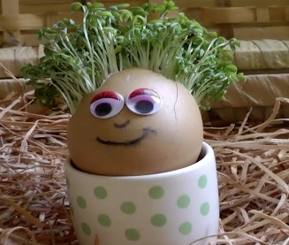  Grow a Cress Head and display in a decorated egg box  How to do it – Hard boil an egg, enjoy eating the egg but don’t take away to much of the shell top. Wet some cotton wool and put it on top of some kitchen paper. Fill the empty eggshell with the kitchen roll and cotton wool. Make sure there is a gap between the cotton wool and the top of the eggshells. Put some cress seeds on the cotton wool and press them down gently. Put your eggshells in a sunny, warm spot - try a kitchen windowsill. Decorate your old egg box and egg head. With thanks from www.planet-science.com
79 | Make a vegetable animal
80 | A fingerprint picture
81 | A Rocket made of recyclables
82 | Picture drawn or painted
82a | Largest Sunflower Head
83 | Decorate a flowerpot
84 | 5 Decorated funny face cakes
85 | A drawing of a rainbow (max size A4 on any type of medium)
86 | Specimen handwriting – Entrants in Key Stage 1 (Year 1 or 2) on 29th August 2025. Copy the poem below onto an A4 piece of paper and please decorate your poem around the border, only your handwriting will be judged but the borders look very colourful  The Pancake  Mix a pancake,  Stir a pancake.  Pop it in the pan,  Toss the pancake:  Catch it if you can!  Anon

Class | SECTION I – OLDER PRIMARY SCHOOL CHILDREN  CLASSES 87-95
Entrants must be aged 8 to 11 years (Key Stage 2) on 29th August 2025. Please put your age on the exhibit with an extra label
87 | Miniature garden in a standard seed tray (max size 26cm x 38cm)
87a | Make a model room in a shoe box of your favourite book or TV show
88 | A picture of a garden in any medium
89 | A paper plane made from an A4 piece of paper
This will be judged by how far it flies on the morning of the show. We sadly can’t guarantee the safety of your plane as it will be flown.
90 | A Lego model no bigger than 31cm x 31cm please
91 | Decorate a wooden spoon or wooden spatula
92 | A person or animal out of fruit and/or vegetables
93 | Posy of flowers in a jam jar
94 | Design a “Birthday” card e.g., drawn, painted, printed max size A4
94a | Chocolate Chip Cookies any recipe (this can include Gluten Free/Dairy Free/Vegan etc if you wish, please indicate accordingly)
95 | Specimen handwriting. Please copy the following poem onto A4 paper please decorate your poem around the border if you would like to. Only your handwriting will be judged but the borders do look very pretty  My Missing Shoe  I looked for you by the front door,  Under my bed, on the bathroom floor,  Near the back stairs, in the drawer with my socks,  Next to the table, and out in the sandbox.  My mother is calling me, and I’m calling you,  Where have you gone, my missing shoe?  By Kate Miller-Wilson

Class | SECTION J – YOUNG PERSONS CLASSES 96-99
Entrants aged 11 onwards from 29th August 2025 up to 16 years as of 29th August
For the photography classes 96 & 97 Entrants aged 8–11-years can also enter.
Please put your age on the exhibit with an extra label
 | Photography
96 | Pets or animals
97 | A funny picture with a caption please
 | Size of print no larger than 7”x5” or 180mm x 125mm, unframed and unmounted. Only one entry per class per person
 | Crafts
98 | Colour wheel (Colour wheel template below is just an example of colours to be used, it can be any medium for example paint, crayon, flower, sweets etc)  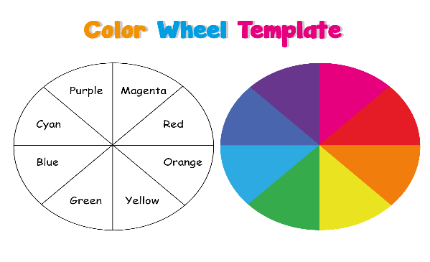
98a | A Headdress (any medium)
 | Cookery
99 | Chocolate Oat Cakes a recipe from 1945 in support of 80th Anniversary of VE day. (see recipe below)

Class 99 CHOCOLATE OAT CAKES
1oz margarine
1oz cooking fat
8oz self-raising flour
1 breakfast cup rolled oats
2oz sugar
salt
1.5oz cocoa powder
milk and water

Rub the fats into the flour. Add oats, sugar, salt and cocoa
Mix well adding a little milk and water to moisten. Roll out very thinly, cut into rounds and prick all over with a fork.
Bake in a moderate oven for about 15 mins until golden brown.

A moderate oven being; Gas mark 4, Conventional electric oven 180c Fan assisted oven 160c

Class | SECTION K – HANDICRAFT CLASSES 100-108
100 | An item of Hand Knitting or Crochet
101 | Picture in any medium  need not be framed, max size 40cm x 30cm. e.g. drawn, painted, collage, felt, pen and ink, mosaic, machine embroidery or stitched.
102 | A Christmas decoration in felt
103 | A decorated card using any medium  e.g., decoupage, quilling, collage, painted, printed
104 | An item of Quilting or Patchwork
105 | A children's toy in (any medium)
106 | Something new from something old
107 | Item of 3D craft work in any medium  e.g. Origami, piece of pottery, piece of wooden handicraft, metalwork.
108 | A piece of jewellery in any medium  e.g. earrings, necklace, friendship bracelet
109 | An item of embroidery
110 | A Limerick entitled “The Storm”
(Entries for class 110 may be attached to the entry form and posted through the box at Cherry Trees, Penns Lodge, Brinkworth, SN15 5DW with 50p entrance fee.)

 | HELPFUL HINTS
 | Remember to read any specific display instructions in the schedule
 | If a child enters an adult class, please state the age of the child on the front of the entry on a sticker so the judge is aware it is a child’s entry
NFS (Not for Sale) | Please put a NFS (Not for Sale) label on your entry only if you cannot be there at 4.00pm to collect them and would like the item kept aside from the auction
 | Paper plates are useful for displaying lots of different entries
Section A | Where necessary vegetables should be carefully washed to removed soil but in no circumstances should oils or similar be applied in an attempt to enhance their appearance.  Wash with a soft cloth and plenty of water, brushing will damage the skin and spoil the appearance of the exhibit. Retain the natural bloom wherever possible.  Vegetables should be staged as attractively as possible.  Slugs are a gardener’s nightmare – try crushing eggshells and scatter then around vulnerable young plants and seedlings  When Cherry Tomatoes start to form, nip off the end of the flowering truss to encourage bigger fruits
Section B | Compost heaps are reported to be excellent sites for growing marrows.
Section C | Paper plates are useful for displaying fruit entries.  Apples should be staged with the eye uppermost; stalk end downwards do not cut the stalks.  Plums and similar shaped fruits are best laid out in lines across the plate. It is important that the bloom is not disturbed, and the stalks are intact.
Section D | Floral Art a novice is a person who has not previously won a “First” in Floral Art class 29, 30 or 31
Section E | The ideal time to cut flowers for showing is in the evening before the show.  Flowers should be cut with as much stem as possible making a slanting cut to assist the uptake of water.  Sometimes flowers such as chrysanthemums and penstemons may not absorb water easily and the stems can be slip upwards (approx. 75mm) under water to assist.  After cutting, remove sideshoots, unwanted buds and lower leaves place the flowers upright in a container of clean deep water. It is better for this to be done overnight if possible, and then the container of flowers should be placed in a cool dark room until the show the next day.  Many exhibitors carry their exhibits in vases in “milk crates”, making sure that packing prevents excessive movement on the journey.  Don’t forget to bring water and vases to stage your flowers on the day. Stage each vase carefully, ensuring that the stem is neither too long nor too short and that damaged leaves are removed. (If you are a novice have a sneaky look at how other more experienced entrants have stages theirs to work out the best length and which way to face the blooms).  For pot plants “all round effect” is important. While growing turn your plants every few days particularly just before the show. If necessary, flowers and leaves should be gently “teased” our so that the plant is displayed at its best.
Section F | Photography the size of print should be no larger than 18cm x 12.5 cm (7” x 5”). Only one entry per class per person
Section G | Jars or jam, curd, honey or marmalade or chutney remember to put the date it was made on the label.  Put baked goods on a plate.  Cover baked goods with clingfilm.  Paper plates are useful for displaying lots of different entries.  Jars of Chutney should have a new lid not a reused lid from an old jam jar.
Section H | Class 78a – Don’t plant too early or your egg head might need a hair cut
Section I | Class 89 – the plane will be judged by flight distance on the morning of Sunday 31st August. All planes will be flown by the show judge We sadly can’t guarantee the safety of your plane during flight.
Section J | Size of print no larger than 7”x5” or 180mm x 125mm, unframed and unmounted. Only one entry per class per person. For the photography classes 96 & 97 entrants 8-11 years can enter, please put your age on the entries.
Sections H, I, J | Don’t forget to pick up extra stickers at the registration desk on Sunday 31st August if you need them, put your age on your entries

For more information on the Produce and Handicraft Show or Brinkworth Show please go to www.brinkworthflowershow.com

